### **CNNs and their Biological Connection**

discusses the **biological connection of Convolutional Neural Networks (CNNs) to the human visual cortex**. The architecture of CNNs is inspired by our own visual cortex, which is a part of our brain. The video explores an important experiment that laid the foundation for CNNs, providing both biological and historical insights.

The discussion is divided into three main parts:

1. How the human visual cortex works and the flow of visual information in the brain.
2. The Hubel and Wiesel experiment, which was crucial for the development of CNNs.
3. The findings of the experiment and how they were used to create CNNs.

### **Part 1: How the Human Visual Cortex Processes Visual Information**



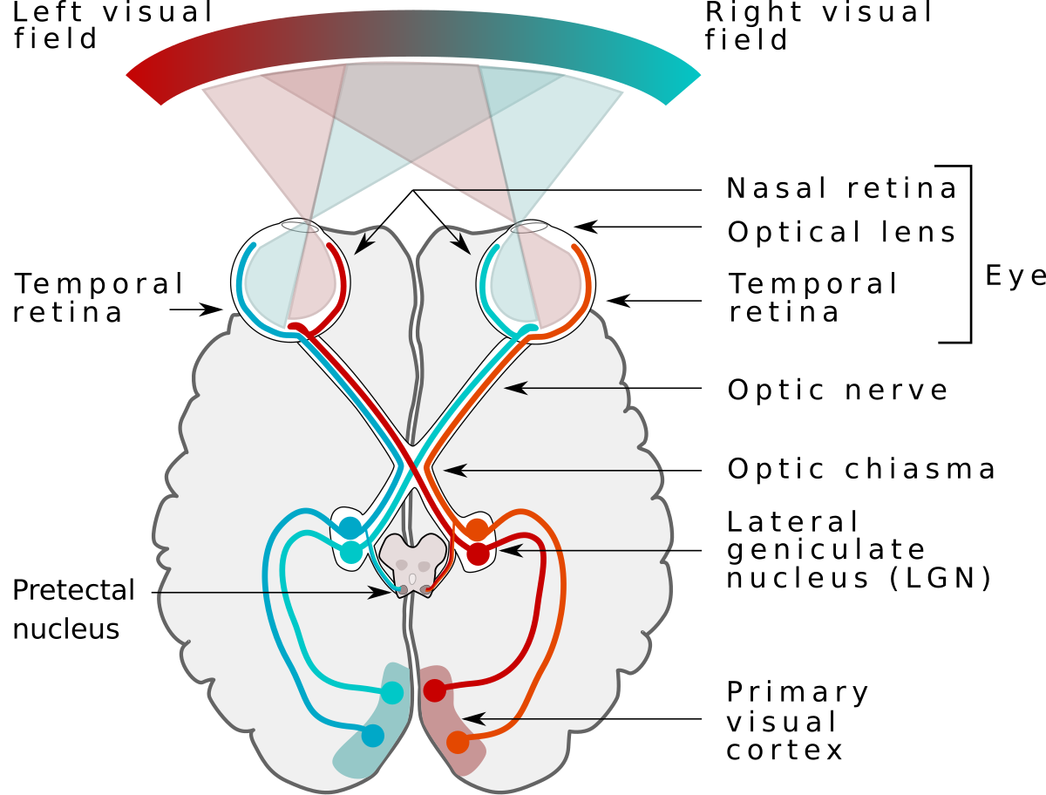

The process of visual perception in the brain, starting from light hitting the eyes, involves a specific pathway:

* **Light Entry:** Light first falls on our **eyes** and then reaches the **retina**. The retina is described as a two-dimensional sheet where light lands.
* **Signal Conversion:** The light detected by the retina is converted into **electrochemical impulses or signals**.
* **Optic Nerve:** These electrochemical signals are then transmitted through the **optic nerve**, which acts like a "pipe" or "bundle of cells/axons".
* **Lateral Geniculate Nucleus (LGN):** The information from the optic nerve reaches a part called the **Lateral Geniculate Nucleus (LGN)**. This nucleus is located within the **thalamus** and performs some **pre-processing** of the light information.
* **Primary Visual Cortex (V1):** After pre-processing in the LGN, the electrochemical signals are then projected to the **Primary Visual Cortex**, also known as **V1**. This V1 area is the initial part of our **visual cortex**, where visual information processing begins. The visual cortex is the entire area of the brain responsible for vision.

**Flow Summary:** Light -> Retina -> Optic Nerves -> Lateral Geniculate Nucleus (LGN, for pre-processing) -> Primary Visual Cortex (V1).

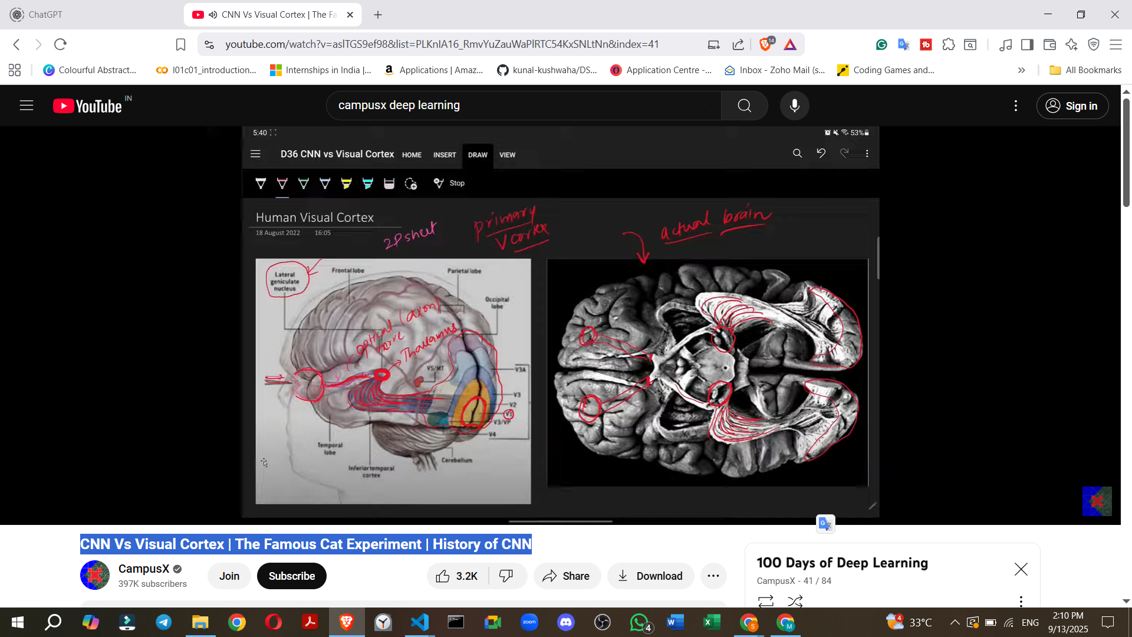

### **Part 2: The Hubel and Wiesel Experiment (The Famous Cat Experiment)**

This section describes a pivotal experiment conducted by **Hubel and Wiesel** around the **1960s**.

* **Scientists:** Hubel and Wiesel.
* **Timeframe:** Around the 1960s.
* **Subjects:** They conducted a series of experiments on **cats and monkeys**.
* **Experimental Setup:**
  + A **cat** was sedated (anaesthetized) in such a way that it was neither completely unconscious nor fully awake; it could see things but its body wouldn't respond, though its brain would.
  + An **electrode** was inserted into the cat's brain at a microscopic level to record the activity of individual cells.
  + A **screen** was placed in front of the cat's eyes.
  + Various **visual inputs**, specifically **shapes and edges**, were displayed on the screen.
  + The **responses from the cat's brain** (electrical signals from the cells) were recorded.

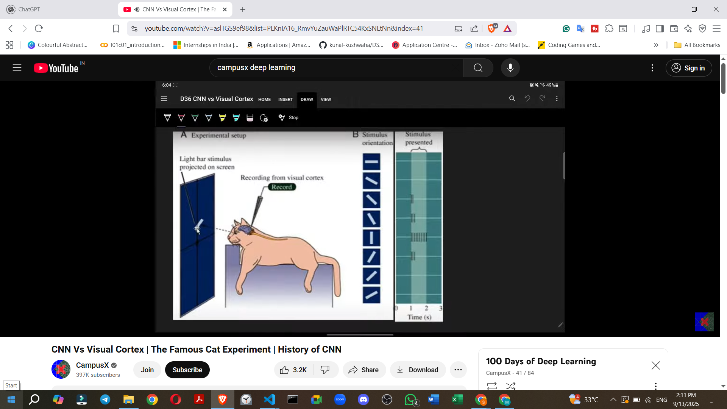

* **Experiment Example and Observations:**
  + Initially, when a **horizontal edge** was shown to the cat, a particular cell in its brain showed **no response**.
  + As the scientists gradually **rotated the edge**, a slight response started to appear.
  + The **strongest response** from that particular cell was observed when the edge was positioned **perfectly vertical**. An electrical spike would be visible, indicating a strong signal.
  + As the edge continued to rotate away from the vertical position, the response began to decrease, and when it returned to horizontal, the response disappeared again.
  + **Conclusion for this cell:** This specific cell was highly effective at **detecting vertical edges**.

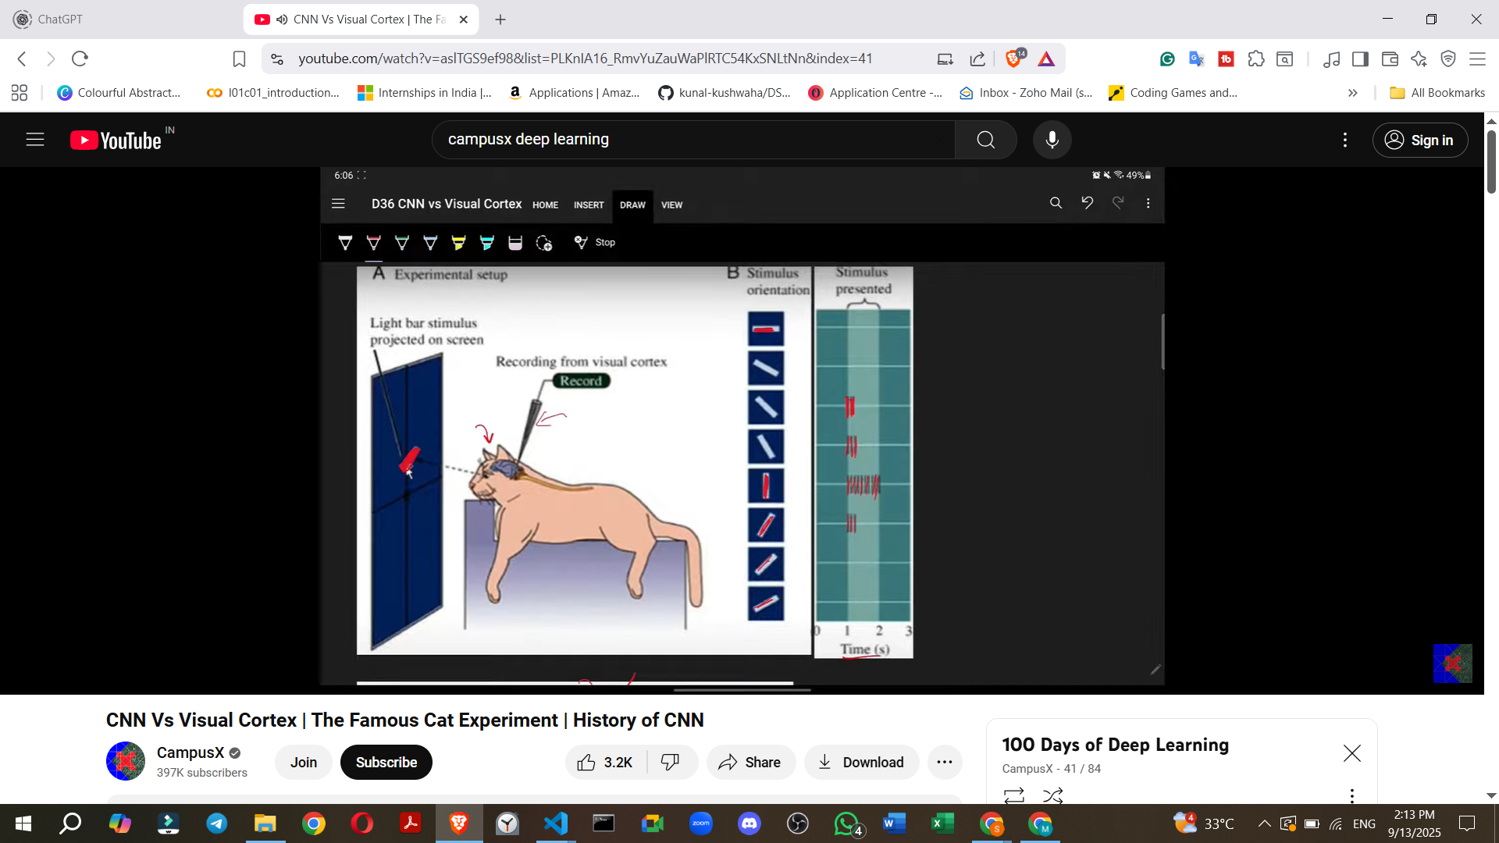

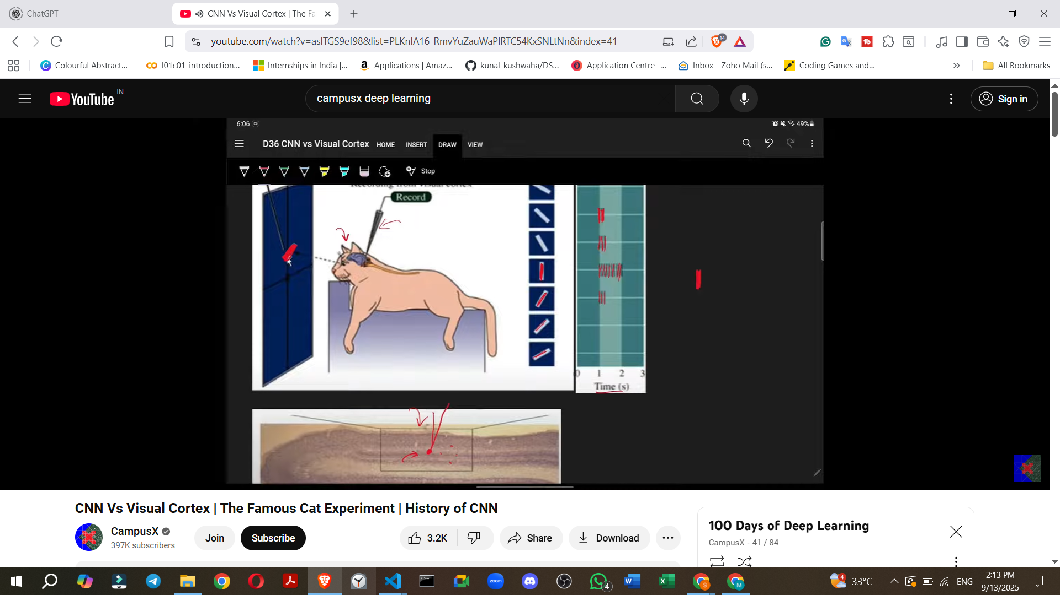

* + **General Observation:** The scientists found that different cells in the cat's visual cortex were **responsive to different types of shapes and edges**. For example, one cell might respond strongly to a horizontal edge, another to a slanted edge, and so on, but each cell only responded to a specific type of shape/edge and not others.

### **Part 3: Conclusions and Findings from the Experiment & Connection to CNNs**

The experiments led to the conclusion that our visual cortex contains two primary types of cells:

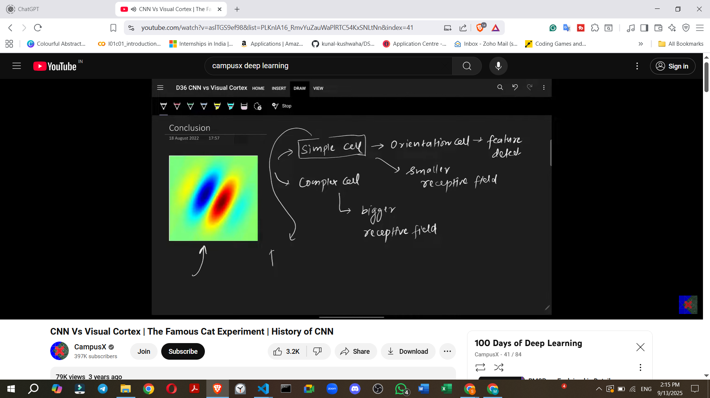

1. **Simple Cells:**
   * Also known as **Orientation Selective Cells** or **Feature Detectors**.
   * They have a **smaller receptive field**, meaning they process a small area of an image.
   * They operate on the principle of **"preferred stimuli"**: A particular simple cell will **only detect one specific type of edge** (e.g., a cell detecting vertical edges will not respond to horizontal or slanted edges).
   * **Function:** Their main job is **edge detection**.
   * **Importance of Edge Detection:** Nature focuses on edge detection because any image, whether it's a **face** or a **circle**, is fundamentally composed of edges. By detecting these basic edges, the visual system starts to process visual information.

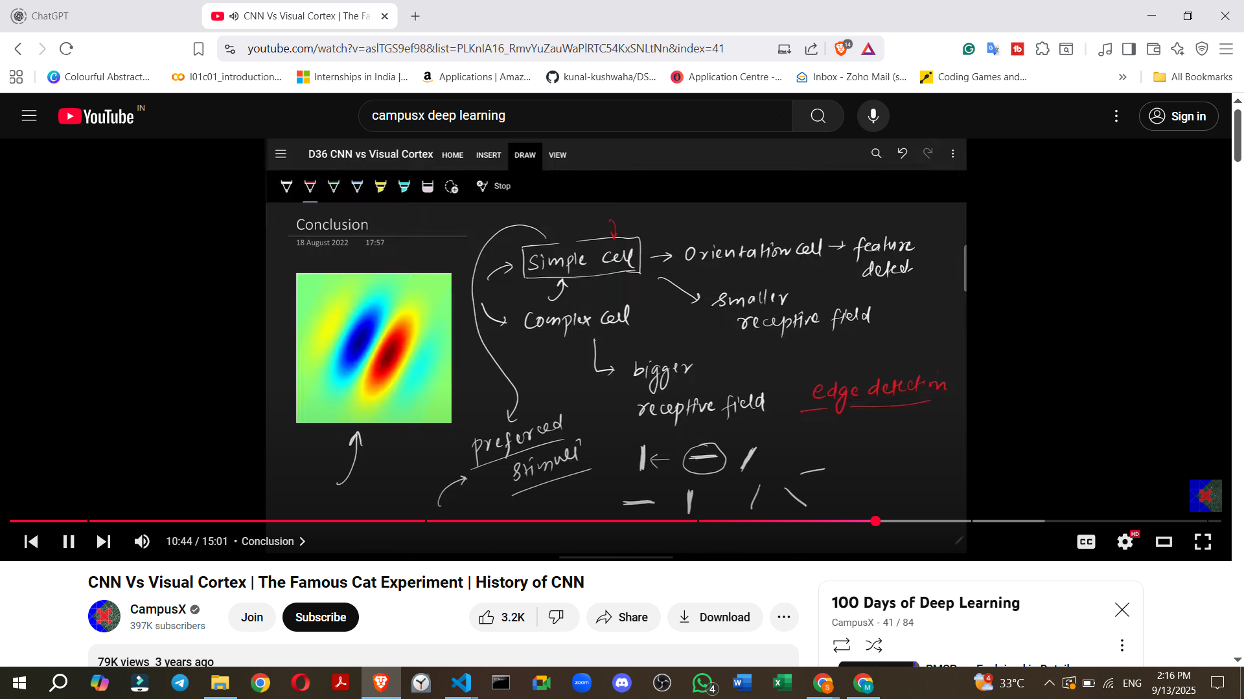

1. **Complex Cells:**
   * They have a **larger receptive field**, allowing them to process a broader area of an image simultaneously.
   * **Function:** Their role is to detect **higher-level features** by taking the information processed by the simple cells.

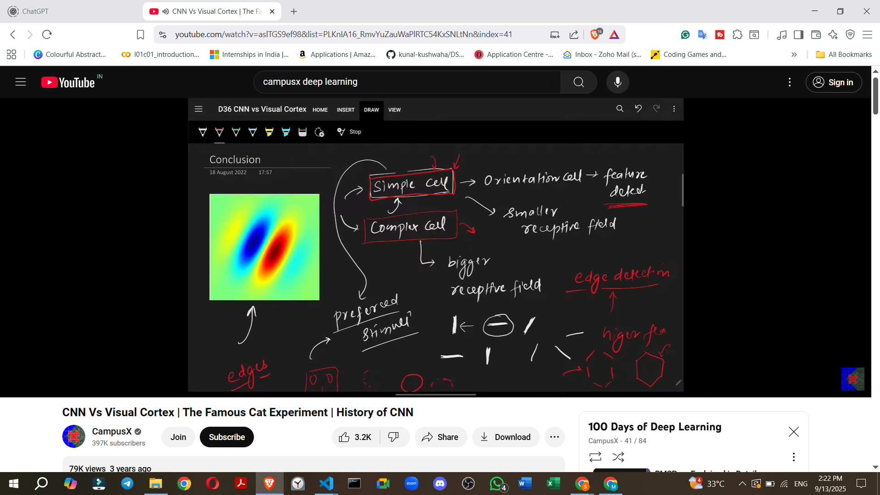

* + **Example:** If simple cells detect individual edges that, when combined, form a **hexagon**, the complex cells would then detect the hexagon itself.
  + **Hierarchy:** The visual cortex is structured such that simple cells detect basic features (like edges), and then complex cells combine these basic features to detect more complex patterns. Further layers of complex cells detect even more intricate patterns, eventually enabling the processing of an entire image.

**Overall Principle:** The visual cortex works by first using simple cells to detect basic features (like edges). This information is then passed to complex cells, which use these basic features to detect progressively more complex patterns, eventually leading to the comprehensive processing of an entire image.

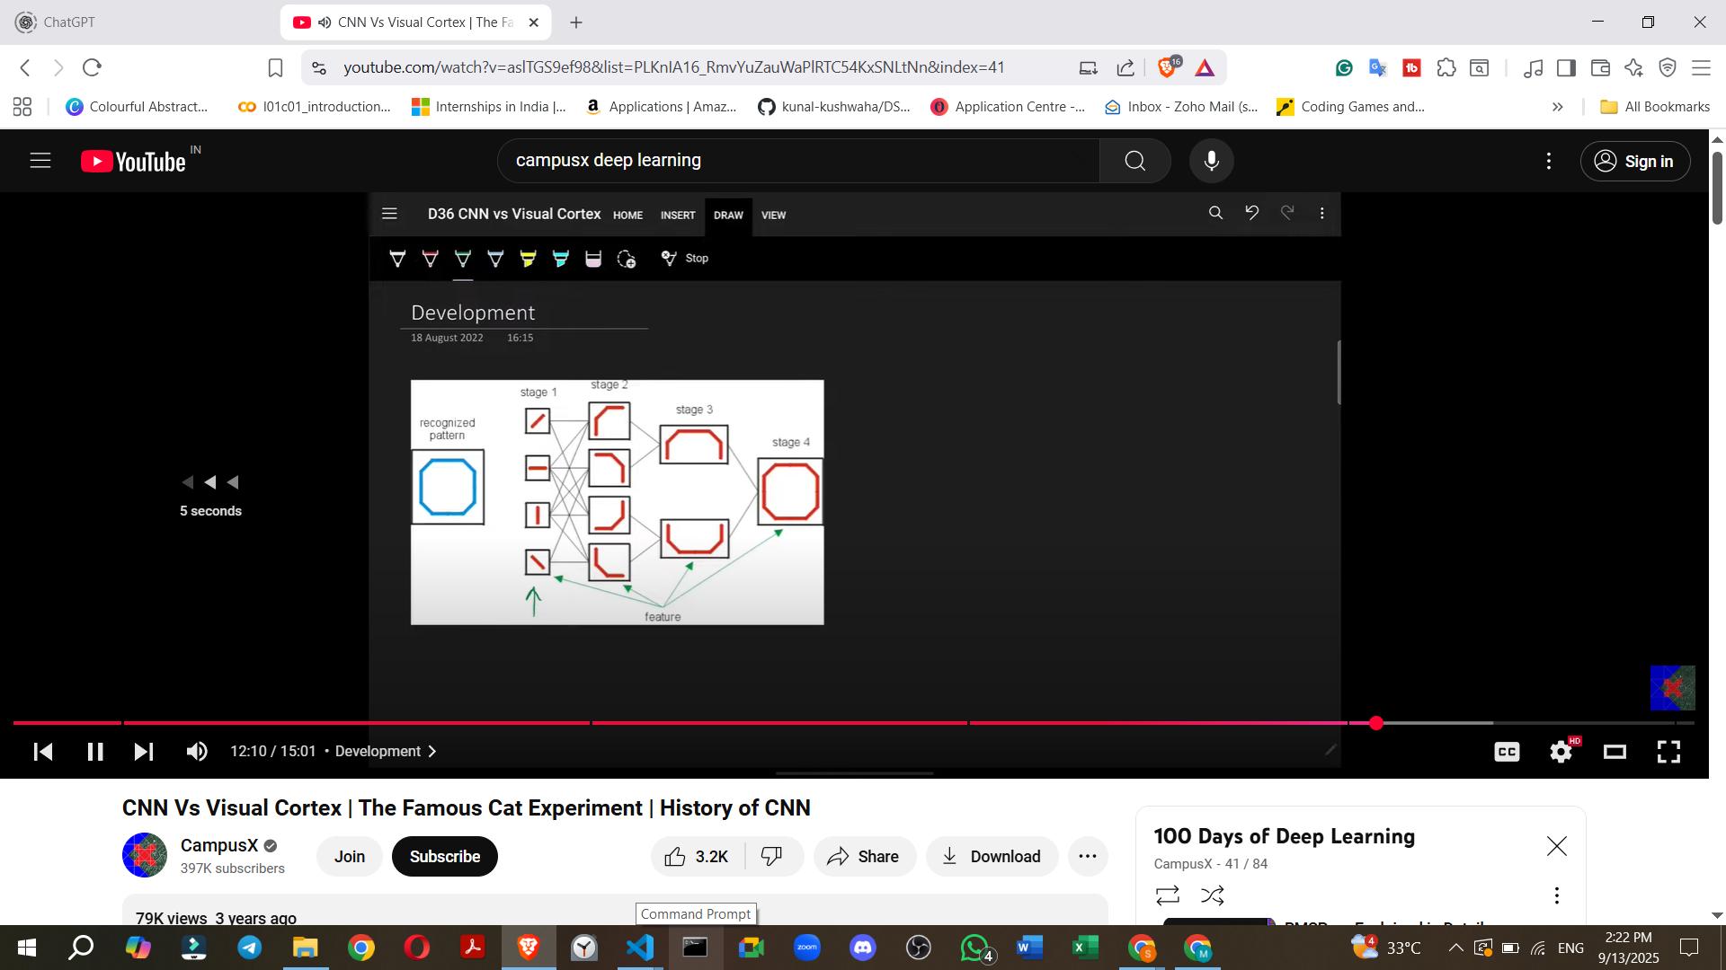

### **Connection to Convolutional Neural Networks (CNNs)**

The principles discovered from the Hubel and Wiesel experiments became a significant **inspiration for computer scientists**.

* **Early Model: Neocognitron**
  + **Scientist:** Developed by Japanese scientist **Kunihiko Fukushima**.
  + **Purpose:** It was designed for **pattern recognition of Japanese characters**.
  + **Structure:** It used two types of cells, **S-cells and C-cells**, which operated on the same principle as simple and complex cells.
  + **Functionality:** Early layers detected simple patterns or features (like edges), and as the network progressed, it gradually detected more complex patterns.
  + **Limitation:** The Neocognitron was not robust or effective enough in its performance.

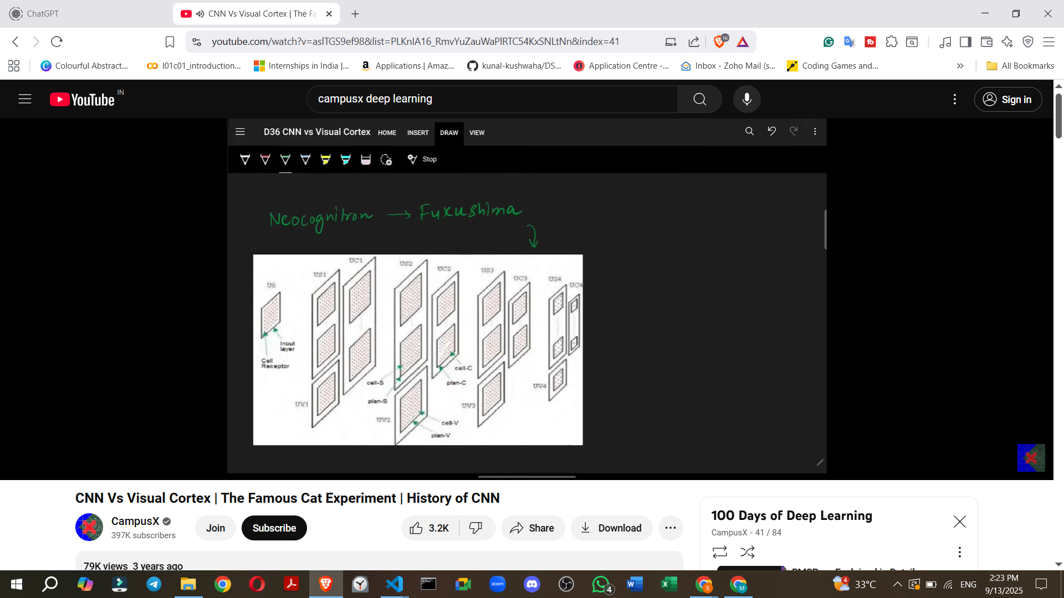

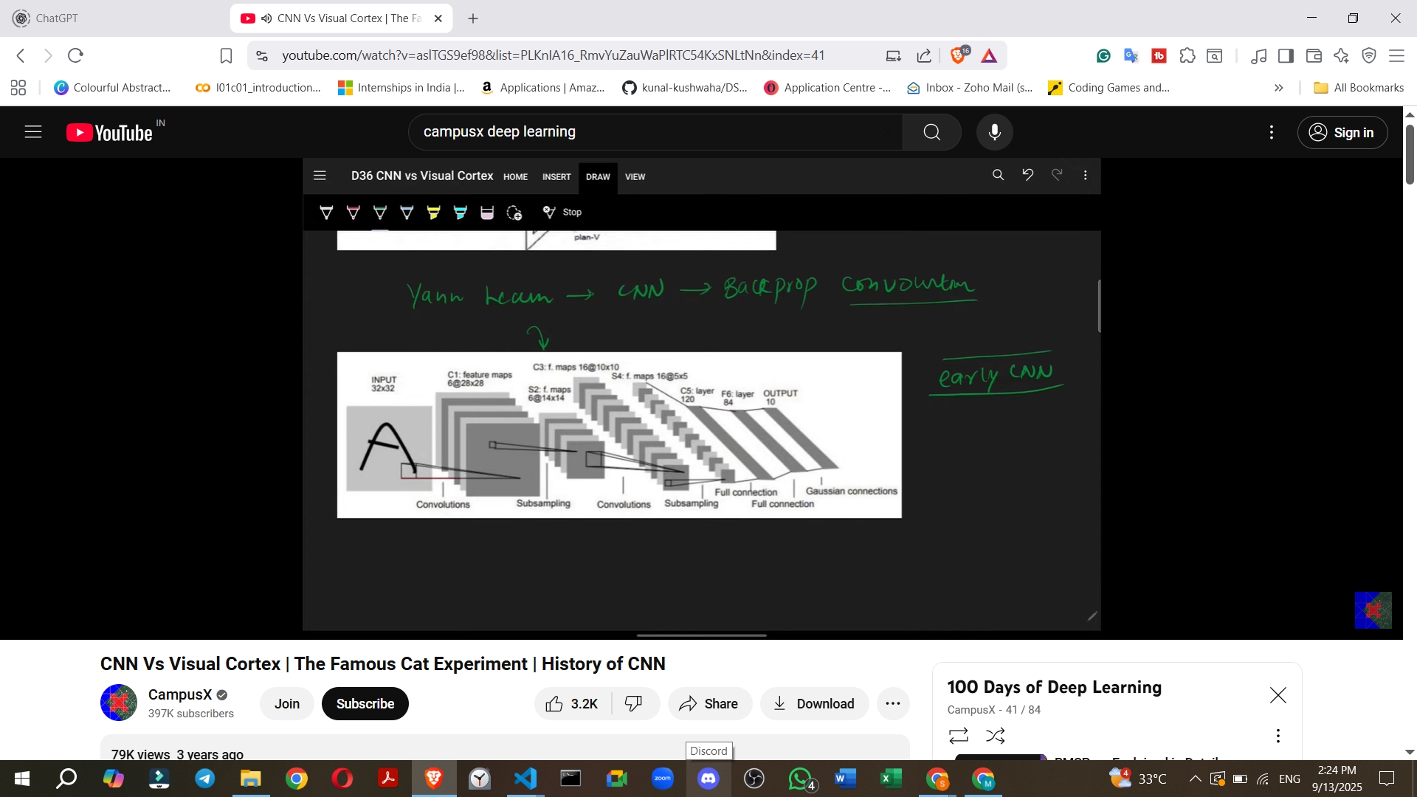

* **Modern CNNs**
  + **Yann LeCun (1990s):** He developed his own **CNN architecture** in the 1990s.
  + **Key Components:** His architecture incorporated **backpropagation** and **pooling layers**.
  + **Application:** This model was highly effective for **scanning checks**.
  + **Significance:** This marked the **beginning of serious research into CNNs**.
  + **AlexNet (2012):** A significant breakthrough occurred in 2012 when **AlexNet** won the **ImageNet competition**, showcasing the power of CNNs.  
    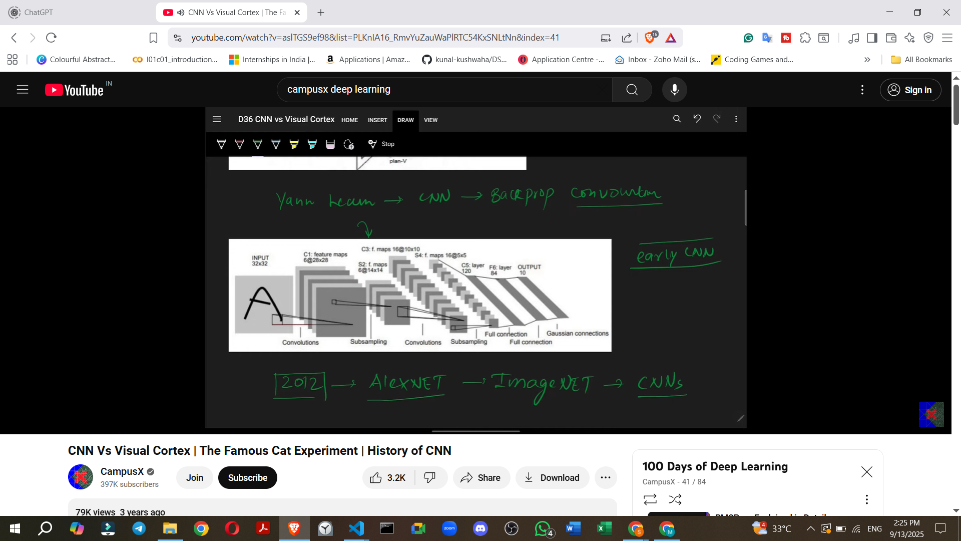
  + **Further Developments:** Since then, many other CNN architectures have emerged and are continuously being developed.

This historical and biological connection highlights how insights into the human visual system directly influenced the development and architecture of modern CNNs.